Protocol for Weaning from Mechanical Ventilation
Version | Date
First proposal | 2010.03.30
1st Revision | 2010.07.07
2nd Revision | 2011.04.19
3rd Revision | 2012.08.03
4th Revision | 2013.04.15
5th Revision | 2015.01.15
6th Revision | 2017.08.01
7th Revision | 2019.07.01
8th Revision | 2026.04.21

- Definitions and Classification
  - Weaning (Process of Discontinuing Ventilatory Support)
        - A process aimed at gradually reducing and ultimately discontinuing mechanical ventilation
        - Patients on mechanical ventilation may develop various iatrogenic complications (hemodynamic instability, increased sedation requirement, ventilator-associated pneumonia, gastrointestinal bleeding, muscle wasting and weakness, etc.); therefore, weaning should be attempted as early as possible through daily screening
  - WIND Classification of Weaning Process and Results
    - Short weaning: the first separation attempt resulted in termination of the weaning process within 1 day (successful separation or early death)
    - Difficult weaning: weaning was completed after more than 1 day but in less than 1 week after the first separation attempt (successful separation or death)
    - Prolonged weaning: weaning was not terminated by 7 days after the first separation attempt (by successful separation or death)

- Weaning Procedure
For all patients on mechanical ventilation for ≥ 24 hours, perform the following procedures sequentially
  - Daily screening for Readiness to Wean
    - Factors to assess readiness for weaning
      - Evidence for some reversal of the underlying cause for respiratory failure
      - Adequate oxygenation (e.g., PF ratio >200, requiring PEEP ≤ 5cmH2O, FiO₂ ≤ 0.4)
      - Hemodynamic stability
      - Capability to initiate an inspiratory effort
    - Assessment criteria
Clinical assessment
- Adequate cough
- Absence of excessive tracheobronchial secretion
- Resolution of disease acute phase for which the patient was intubated
Objective measurements
- Clinical stability
- Stable cardiovascular status: Heart rates ≤ 120 bpm, Systolic blood pressure 90-140 mmHg, no or minimal vasopressor (dopamine/dobutamine ≤ 5μg/kg/min, norepinephrine ≤ 0.05 μg/kg/min)
- Stable metabolic status
- Adequate oxygenation
- SaO₂ > 90% on FiO₂ ≤ 0.4 or PF ratio > 200
- PEEP ≤ 5cmH₂O
- Adequate pulmonary function
- Respiratory rates < 35 breaths/min
- Negative inspiratory pressure (NIP) ≤ −15 cmH₂O
- Tidal volume > 5 mL/kg
- Minute ventilation < 10–15 L/min
- Rapid shallow breathing index (RSBI) < 105
- No significant respiratory acidosis
- Adequate mentation
- No sedation, or adequate mentation on sedation
    - Measurement methods for key indices
      - Negative inspiratory pressure (NIP)
        - The lowest airway pressure measured during voluntary inspiration over a 20-second end-expiratory pause
      - Rapid shallow breathing index (RSBI)
        - Measured during 3-minute application of Continuous Positive Airway Pressure (CPAP) at 5 cmH₂O
        - RSBI = [respiratory rate (breaths/min)] / [tidal volume (L)]
  - Spontaneous Breathing Trial (SBT)
    - Method
      - Ventilator settings
        - Pressure Support Ventilation (PSV), 8 cmH₂O, PEEP 0 cmH₂O
        - FiO₂ kept the same as immediately before SBT, usually 40%
      - Evaluation period: 30–120 minutes of sustained spontaneous breathing
        - First trial: 30 minutes
        - Second or subsequent trials, or in case of prolonged weaning: 120 minutes
      - Monitoring
        - Arterial blood gas analysis
          - Performed 30 minutes after the first trial; 120 minutes after the second/subsequent trial or in prolonged weaning
          - If respiratory distress occurs during SBT, immediately perform follow-up arterial blood gas analysis and reconnect the ventilator
        - Vital signs: measured every 5 minutes as a rule; if invasive monitoring is unavailable, every 15 minutes
    - Failure criteria of spontaneous breathing trial
Clinical assessment
- Agitation and anxiety
- Depressed mental status
- Diaphoresis
- Cyanosis
- Evidence of increasing effort
- Increased accessory muscle activity
- Facial signs of distress
- Dyspnea
Objective measurements
- PaO₂ < 60 mmHg or SaO₂ < 90% on FiO₂ ≥ 0.4
- PaCO₂ > 45 mmHg or increase ≥ 20% from pre-SBT,
and pH < 7.32 with pH decrease ≥ 0.07
- RR > 35/min or increase ≥ 50%
- HR > 140/min or increase ≥ 20%
- SBP > 180 mmHg or increase ≥ 20%
- SBP < 90 mmHg
- Cardiac arrhythmias
  - Extubation
    - After confirming the following, decide whether to extubate
      - Achievement of adequate oxygenation and ventilation with spontaneous breathing
      - Minimal risk of upper airway obstruction
        - Based on clinical judgment; for cuff-leak test–based preemptive approach, see Section V
      - Adequate airway protection and minimal risk of aspiration
      - Adequate clearance of pulmonary secretion
    - Criteria for extubation failure within 48 hours after extubation
- Respiratory rate > 35/min sustained for ≥ 2 hours
- HR > 140/min, or sustained increase/decrease ≥ 20%
- Clinical signs of respiratory muscle fatigue or increased work of breathing
- Inadequate oxygenation: PaO₂ < 60 mmHg or SaO₂ < 90% on FiO₂ ≥ 0.4
- Inadequate ventilation: PaCO₂ > 45 mmHg or increase ≥ 20% from pre-extubation

- Common Problems in Difficult or Prolonged Weaning
  - Respiratory Problems
        - Increased work of breathing: inappropriate ventilator settings
        - Reduced lung compliance: ventilator-associated pneumonia, cardiogenic or non-cardiogenic pulmonary edema, pulmonary fibrosis, pulmonary hemorrhage, diffuse pulmonary infiltration
        - Airway bronchoconstriction
        - Increased resistive load
        - During SBT: endotracheal tube resistance
        - Post-extubation: glottic edema, increased airway secretions, sputum retention
  - Cardiovascular Problems
        - Underlying cardiac dysfunction
        - Increased cardiac workload that may lead to myocardial dysfunction: dynamic hyperinflation, increased metabolic demand, unresolved sepsis
  - Neuromuscular Problems
        - Decreased central drive: metabolic alkalosis, mechanical ventilation itself, sedatives/hypnotics
        - Central ventilatory command abnormalities: dysfunction of the neuromuscular respiratory system
        - Peripheral dysfunction: primary neuromuscular weakness, critical illness neuromyopathy (CINM)
  - Neuropsychiatric Problems
        - Delirium, anxiety, depression
  - Metabolic Problems
        - Metabolic disturbance, corticosteroid use, hyperglycemia
  - Others
        - Overweight, malnutrition, ventilator-induced diaphragmatic dysfunction, anemia

- Post-Extubation Respiratory Support: Risk-Stratified Approach
  - General Considerations
        - Post-extubation reintubation risk varies among patient groups (10–30%); reintubation significantly increases mortality
        - Therefore, post-extubation respiratory support should be applied differentially according to reintubation risk
        - Evidence: HIGH-WEAN trial (Thille et al., JAMA 2019) and Hernández et al. (JAMA 2016)
  - Reintubation Risk Assessment (high-risk criteria)
At extubation, classify as high-risk for reintubation if one or more of the following apply (HIGH-WEAN criteria):
    - Age > 65 years
    - Underlying chronic cardiac disease:
        - Left ventricular dysfunction (LVEF ≤ 45%, regardless of cause)
        - History of cardiogenic pulmonary edema
        - Documented ischemic heart disease
        - Permanent atrial fibrillation
    - Underlying chronic lung disease:
        - Chronic obstructive pulmonary disease
        - Obesity-hypoventilation syndrome
        - Chronic restrictive pulmonary disease
  - Respiratory Support in the Low-risk Group — High-Flow Nasal Cannula (HFNC) Alone
    - Indication: applied to patients not meeting the above criteria (reintubation risk < 10%)
        - Evidence: Hernández JAMA 2016 low-risk trial
    - Method
      - Initial settings: O₂ flow 30 L/min, FiO₂ 40%
        - Patients often report discomfort on first HFNC application; therefore, start at 20 L/min and gradually increase to the target 30 L/min
        - Increase settings as patient O₂ or flow requirement rises
      - Reduce flow to 25 L/min the next morning and switch to nasal cannula if arterial blood gas analysis is acceptable 30 minutes later
  - Respiratory Support in the High-risk Group — Alternating HFNC and Prophylactic Non-invasive Ventilation (NIV)
    - Evidence
In the HIGH-WEAN trial, the post-extubation HFNC + intermittent NIV group had a significantly lower 7-day reintubation rate compared with HFNC alone (11.8% vs 18.2%, p = 0.02; post-extubation respiratory failure 21% vs 29%, p = 0.01)
    - Method
      - Schedule
        - Start NIV immediately after extubation
          - First session: at least 4 continuous hours
          - Maintain NIV at least 12 hours per day during the first 48 hours after extubation
          - Continuous application is recommended overnight
        - Maintain HFNC (50 L/min) between NIV sessions
        - After 48 hours, discontinue if respiration is stable and switch to standard oxygen therapy; extend treatment if respiration is unstable
      - NIV settings
        - Use ICU ventilator NIV mode or a dedicated NIV device
        - Pressure-support mode: PS ≥ 5 cmH₂O, target tidal volume 6–8 mL/kg of predicted body weight
        - PEEP 5–10 cmH₂O
        - Adjust FiO₂ to maintain SpO₂ ≥ 92%
      - HFNC settings (between NIV sessions)
        - Flow 50 L/min; adjust FiO₂ to maintain SpO₂ ≥ 92%
        - Heated humidifier set to 37 °C
  - Monitoring and Rescue Therapy
    - Arterial blood gas analysis: within 1 hour after extubation
        - HFNC alone group: tested during HFNC application
        - NIV group: tested during NIV application
    - When post-extubation respiratory failure occurs
      - Consider reintubation without delay if extubation failure criteria or severe respiratory failure criteria are met
      - Rescue NIV is not recommended once post-extubation respiratory failure is established
        - Reintubation delay increases mortality (Esteban et al., NEJM 2004; ERS/ATS guideline 2017)

- Post-Extubation Laryngeal Edema
Post-extubation laryngeal edema is upper airway inflammatory edema caused by mechanical injury from the endotracheal tube. It occurs in approximately 20% of all patients and is one of the most common causes of post-extubation reintubation.
  - Risk Factors for Post-extubation Stridor
Patients with one or more of the following are classified as high-risk and should undergo cuff-leak test before extubation (Evidence: Kuriyama, 2020, Crit Care — meta-analysis of 28 studies / 4,493 extubations):
      - Traumatic or difficult intubation
      - Prolonged intubation (> 6 days)
      - Large endotracheal tube relative to airway diameter
      - Previous reintubation history
      - Asthma, gastroesophageal reflux disease, or known airway inflammation
  - Cuff-leak Test (CLT)
    - Measurement method
      - Adequately suction oral and airway secretions before testing
      - With the endotracheal tube cuff inflated, set the ventilator to volume control ventilation and measure the inspiratory tidal volume
      - After deflating the cuff, measure expiratory tidal volume during 6 breaths in spontaneous breathing or volume control ventilation
      - Cuff-leak volume = (tidal volume with cuff inflated) − (mean of the 3 lowest expiratory tidal volumes after cuff deflation)
    - Interpretation
        - Failed CLT criteria: leak volume < 110 mL or < 12% of delivered tidal volume
        - Diagnostic accuracy (Kuriyama 2020 meta-analysis)
          - High specificity but moderate sensitivity: a positive result justifies intervention, but a negative result alone cannot fully exclude the possibility of laryngeal edema
    - Preemptive systemic steroid therapy in patients with failed CLT
      - Recommended regimen: Methylprednisolone 40 mg IV single dose at least 4 hours before extubation
      - Evidence: 2017 ATS/ACCP conditional recommendation (moderate evidence) — “For adults who have failed a cuff-leak test but are otherwise ready for extubation, administer systemic steroids for at least 4 hours before extubation.”
  - Diagnosis
      - Direct laryngoscopic visualization (gold standard)
      - Post-extubation stridor: hallmark clinical manifestation
      - Quantitative cuff-leak test: predictor for post-extubation stridor
  - Treatment
      - Conservative treatment including oxygen administration
      - Nebulized epinephrine (1:1000 solution 1 mL diluted in 2 mL saline); repeat every 30–60 minutes as needed

- Weaning protocol flowchart in SMC
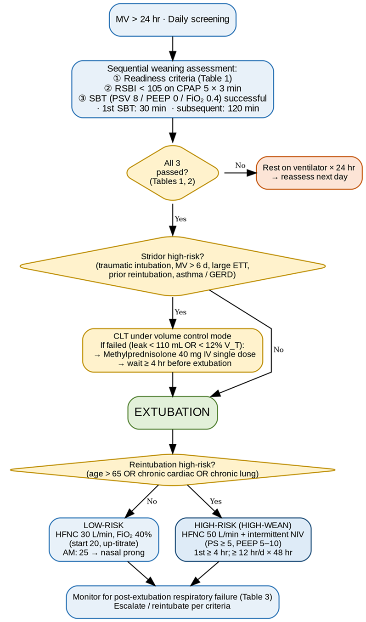

- References
  - Weaning Process and SBT
        - Boles JM, Bion J, Connors A, et al. Weaning from mechanical ventilation. Statement of 6th International Consensus Conference on Intensive Care Medicine. Eur Respir J 2007;29:1033-1056.
        - MacIntyre NR, Cook DJ, Ely EW, et al. Evidence-based guidelines for weaning and discontinuing ventilatory support. Chest 2001;120:375S-395S.
        - MacIntyre NR. Discontinuing mechanical ventilatory support. Chest 2007;132:1049-1056.
        - Ouellette DR, Patel S, Girard TD, et al. Liberation from mechanical ventilation in critically ill adults: An official ACCP/ATS clinical practice guideline: inspiratory pressure augmentation during SBTs, protocols minimizing sedation, and NIV immediately after extubation. Chest 2017;151:166-180.
        - Subirà C, Hernández G, Vázquez A, et al. Effect of pressure support vs T-piece ventilation strategies during SBT on successful extubation. JAMA 2019;321:2175-2182.
        - Béduneau G, Pham T, Schortgen F, et al. Epidemiology of weaning outcome according to a new definition. The WIND Study. Am J Respir Crit Care Med 2017;195:772-783.
  - Post-extubation Respiratory Support
        - Thille AW, Muller G, Gacouin A, et al.; HIGH-WEAN Study Group and REVA Research Network. Effect of postextubation high-flow nasal oxygen with noninvasive ventilation vs high-flow nasal oxygen alone on reintubation among patients at high risk of extubation failure: a randomized clinical trial. JAMA 2019;322:1465-1475.
        - Hernández G, Vaquero C, González P, et al. Effect of postextubation high-flow nasal cannula vs conventional oxygen therapy on reintubation in low-risk patients: a randomized clinical trial. JAMA 2016;315:1354-1361.
        - Hernández G, Vaquero C, Colinas L, et al. Effect of postextubation high-flow nasal cannula vs noninvasive ventilation on reintubation and postextubation respiratory failure in high-risk patients: a randomized clinical trial. JAMA 2016;316:1565-1574.
        - Rochwerg B, Brochard L, Elliott MW, et al. Official ERS/ATS clinical practice guidelines: noninvasive ventilation for acute respiratory failure. Eur Respir J 2017;50:1602426.
        - Oczkowski S, Ergan B, Bos L, et al. ERS clinical practice guidelines: high-flow nasal cannula in acute respiratory failure. Eur Respir J 2022;59:2101574.
  - Post-extubation Laryngeal Edema and Steroid
        - Girard TD, Alhazzani W, Kress JP, et al. An Official ATS/ACCP Clinical Practice Guideline: Liberation from mechanical ventilation in critically ill adults. Rehabilitation protocols, ventilator liberation protocols, and cuff leak tests. Am J Respir Crit Care Med 2017;195:120-133.
        - Kuriyama A, Umakoshi N, Sun R. Prophylactic corticosteroids for prevention of postextubation stridor and reintubation in adults: a systematic review and meta-analysis. Chest 2017;151:1002-1010.
        - Kuriyama A, Jackson JL, Kamei J. Performance of the cuff leak test in adults in predicting post-extubation airway complications: a systematic review and meta-analysis. Crit Care 2020;24:640.
        - Feng IJ, et al. Comparative efficacies of various corticosteroids for preventing postextubation stridor and reintubation: a systematic review and network meta-analysis. Front Med (Lausanne) 2023;10:1135570.

